FROM GENNADI VILLAGE SQUARE (SUPERMARKET) TO PARKING SPOT 1

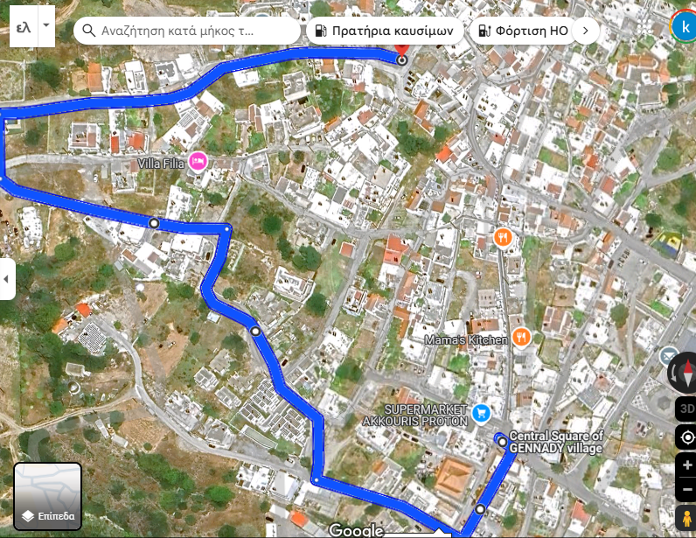

---------------------------------------------------------------------------------------------------------------------------

FROM GENNADI VILLAGE SQUARE (SUPERMARKET) TO PARKING SPOT 2

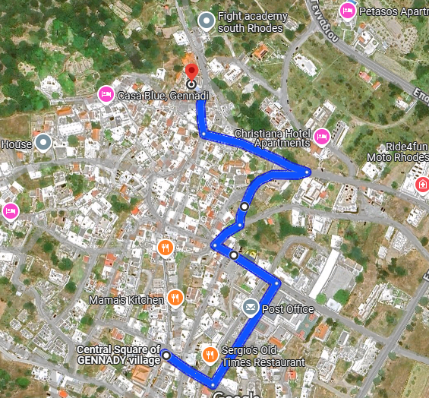

FROM GENNADI VILLAGE SQUARE (SUPERMARKET) TO PARKING SPOT 3

